**Project Proposal**

**Micheál Mc Eneaney – G00296808**

**Project: Video Game**

**Supervisor: Paul Dunne**

**The Idea**

For my project, I have decided to write a Video Game. I have chosen this topic as I have a strong interest in gaming. I wish to make a game based around either car racing or a sports game. I wish to make one of these as, along with gaming, I have a strong passion for sports and cars. I plan to integrate networking by adding multiple users to the game. I also wish to incorporate a database so I can have a form of score keeping to keep track of records set.

I plan to write the project using the Unity game development platform. I will be using C# to write the game, which will be a challenge to learn, but as it is like Java, I hope to pick it up quickly by watching tutorials.

**The Technology**

Unity is a cross platform gaming engine which was developed by Unity Technologies. It is used to develop video games for a range of devices, including PC’s, mobiles, and websites. Since its release in 2005, Unity has extended its technologies to a total of 21 platforms. Developers wishing to use Unity, can use a wide variety of languages like C, C++, C# and JavaScript.

Microsoft Visual Studio is an Integrated Development Environment (IDE) developed by Microsoft, to develop computer programs, web sites, web applications and more.

**Architecture**

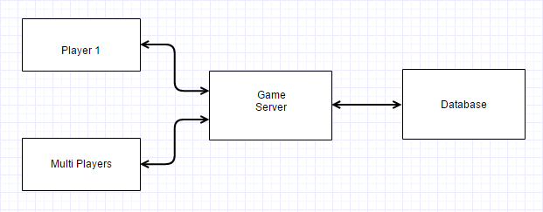

**Extra Ideas**

If I create the main racing game in a reasonable period, I will try to add hardware to control the vehicle by using the Arduino microprocessor.